

“Emerging Women Leaders”
Session 4 Preparation Material

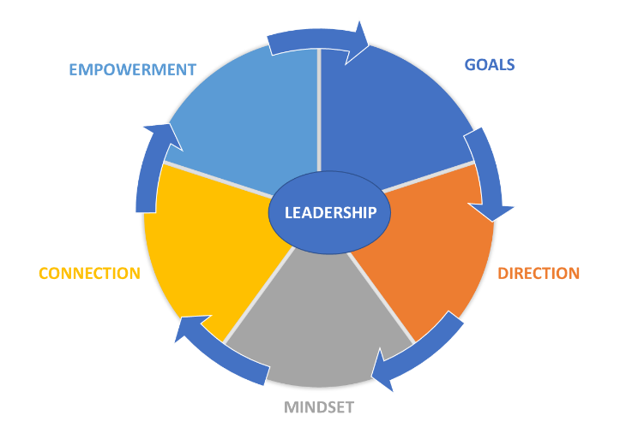
Our Purpose: ‘To inspire, engage, support and create resilience in our next gen. leaders’
SESSION 4 READINGS – CONNECTING – Leading in a Contemporary World.

Session 4 – CONNECTING - Leading in a Contemporary World
- How do you influence others, including current leaders, to support your leadership development?
- What leadership capacity will you need to thrive as a future leader?
- Why will EQ and agility be important in leading diversity in all its forms in a decentralised, e-connected world?

Food for thought
‘Exemplary leaders treat people in a way that bolsters their self-confidence, making it possible for them to achieve more than they may have initially believed possible of themselves. ‘
Source: Kouzes and Posner Everyday People, Extraordinary Leadership, p 137

Connecting - Who do you need around you?
Networking is an essential skill; it's the key to your success. So why are so many of our connections superficial and transactional? And why do they get us nowhere in our personal or professional life? Maybe because we've lost sight of the fact that it's not about the quantity of connections you make, but the quality of the relationships you build and nurture.
This is an absolutely must read and act!!

“It's Who You Know: How to Make Networking Work for You”
https://www.amazon.com.au/Its-Who-You-Know-Networking/dp/0730369536

Who Are You?
Know who you are and how you want to present and communicate when you are networking

Magnetic Stories: Connect With Customers & Engage Employees With Brand Story Telling: Connect with Customers and Engage Employees with Brand Storytelling by Gabrielle Dolan (Author)
https://www.amazon.com.au/Magnetic-Stories-Customers-Employees-Storytelling/dp/0730388514

Improve customer and employee loyalty with your brand stories
Your brand is the stories people share about you when you’re not in the room. Whether a small, one or two-person company or a large multinational; a not for profit or a Government organisation; a start-up entrepreneur or a corporate institution; a school or a sporting team; a religious institution or a political party; a local café or a global franchise ― everyone has a brand and everyone has a story. The reality is people are already sharing stories, both the good and the bad.
Work out who you are!
See attached – Your Stories Your Brand Workbook
Fiona Kerr - Changing Our Minds: How great leaders rewire brains
https://www.youtube.com/watch?v=q6GvsIEOofs
“We shape our brains constantly all through our lives.
How do we do this? How do we shape each other?
How does technology shape us? And how should we shape technology?”

Dr Fiona Kerr is an adjunct with the University of Adelaide. Her research areas include the neurophysiological impact of interaction between humans and with technologies; the ethical use of artificial intelligence; how leaders build better brains and businesses; strategic intuition; and collaboration around wicked problems.
Fiona has a PhD in complex systems engineering and cognitive neuroscience, augmented by degrees in psychology and anthropology. At the University of Adelaide she has collaborated with the Faculty of Health Sciences to examine the neurophysiological impact of human interaction on healing and the therapeutic relationship; and with the Faculty of Engineering on the interaction between humans and trusted autonomous systems for Defence.

How leaders change brains and win hearts | Fiona Kerr | TEDxAdelaide
https://www.youtube.com/watch?v=HPD_5y_Fxhg
Leaders change brains, for better or worse. Good leaders have brains that light up differently when engaging teams, connecting in ways that not only grow trust and empathy, but increase capacity for long-lens, complex problem solving and collaborative creativity.

Take some time for yourself to assess your assets Do the age one for fun. Pam is 41, Chris is 28!!
Click and open Hyperlink
- IQ Test
- EQ Test
- Right Brain Left Brain Test
- Mental Age Test

https://testyourself.psychtests.com/testid/2152
https://www.leadershipiq.com/blogs/leadershipiq/36533569-quiz-whats-your-leadership-style

The Trends Shaping the Future of Work
https://www.youtube.com/watch?v=LrhmHbDLM8o
Jacob Morgan is a best-selling author, keynote speaker, and futurist. He speaks at conferences and events all over the world on the topics of the future of work, employee experience, leadership, innovation, technology, and more! His latest book is The Employee Experience Advantage: How to Win the War on Talent by Giving Employees the Workspaces they want, the Tools they Need and a Culture They Can Celebrate (Wiley, March 2017) which is based on an analysis of over 250 global organizations. Jacob's work has been endorsed by the CEOs of: Cisco, Whirlpool, T-Mobile, Best Buy, SAP, Nestle, KPMG, Schneider Electric and many others.
He is frequently featured in media outlets such as Forbes, USA Today, Fast Company, NPR, the WSJ, and Inc Magazine. He also hosts a weekly podcast show, called The Future of Work, where he interviews senior executives and best-selling authors about the future of work and the future in general.
Jacob is also the founder of "The Future If", a global community of business leaders, authors, and futurists who explore what our future can look like IF certain technologies, ideas, approaches and trends actually happen. The community looks at everything from AI and automation to leadership and management practices to augmented and virtual reality, the 4th industrial revolution, and everything in between. Visit TheFutureIf.com to learn more.

The Gender Impact of AI on Women’s Careers – Forbes
This article considers one question that increasingly stands out in the evolving landscape of artificial intelligence: Is there a connection between the fact that AI is predominantly trained by men and the fact that AI's potential to disrupt jobs predominantly impacts women? Mercer considered this one of many questions as its future of work practice pondered whether women are right to be wary of AI.
Link:https://www.forbes.com/sites/lindsaykohler/2024/05/17/the-gendered-impacts-of-ai-on-womens-careers/

AI Development Needs More Women. Here’s What Leaders Can Do About It

This article explores the gender gap in generative AI. It isn’t just about who uses the tools—it’s also about who builds them. AI developers make crucial decisions—designing models, selecting training data, determining data usage, developing testing protocols—that affect AI’s accountability, accuracy, and societal impact.

Link: https://www.forbes.com/sites/corinnepost/2025/06/03/ai-development-needs-more-women-heres-what-leaders-can-do-about-it/

Mustafa Suleyman – AI As a Digital Species. Mustafa is a visionary leader in AI, he emphasises the importance of digital leadership for AI success. His TED Talk, AI Is Turning into Something Totally New | Mustafa Suleyman, introduces the concept of AI as a "digital species," highlighting the need to move beyond a purely tool-based approach. He suggests that we should see AI as a new partner in all our lives
https://www.youtube.com/watch?v=KKNCiRWd_j0

